[Date]
Windows User
[company name]
Yoga Benefits

Yoga For Good Health
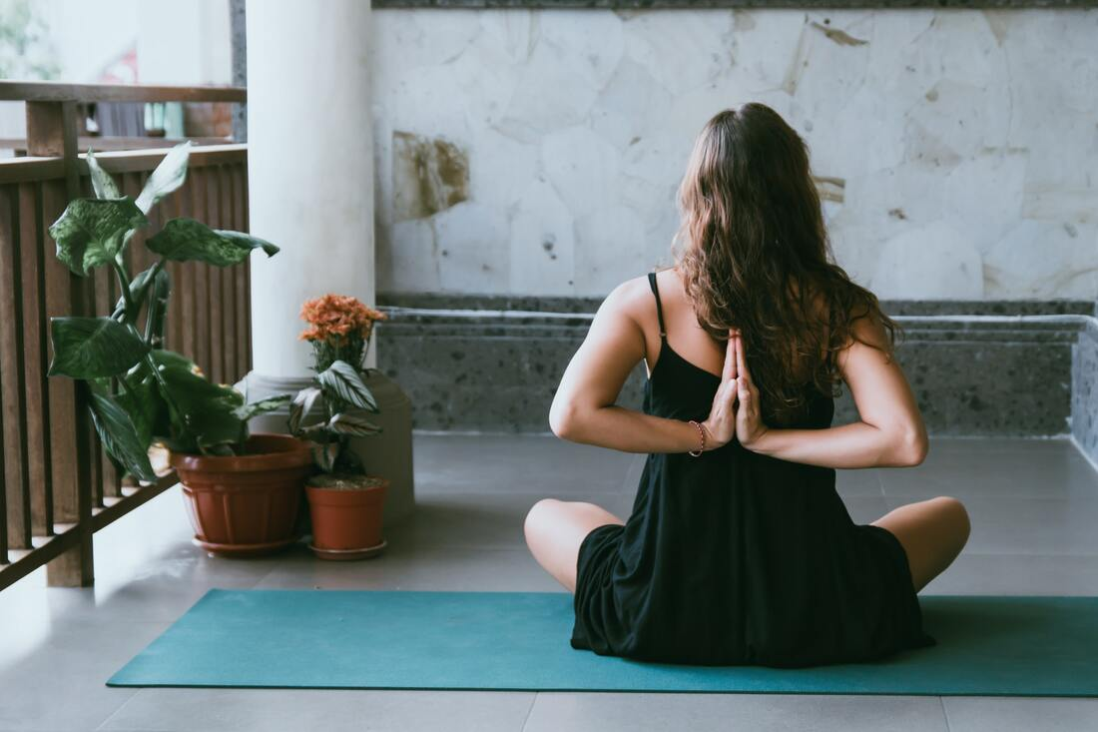
Do you yoga? Have you ever tried?
The first time I tried yoga, when offered as an option in physical education in high school. Did not feel like exercise at first, just some easy stretching. Then we got into some of the most difficult moves or more intense and I really felt the burn. But because I felt so good afterwards, I continued to do some yoga. Now I am one of those people who can put your feet behind your head or balancing on the hands while keeping the rest of my body in a straight line, but I like the practice of breathing and stretching to clear my mind and - stress.
The goals of yoga is physical and spiritual health. Not everyone starts practicing yoga with the aim of spiritual health in mind, but through the daily sessions that have found that just concentrate on breathing as I see improvement in my day. The benefits of yoga are not limited to just physical health. Yoga is used to treat some people who suffer from posttraumatic stress disorder (PTSD). UPS began using yoga therapy to help prevent injuries to their drivers. Their drivers reported feeling more energetic and have a general feeling of well being after their yoga sessions.
5 Health Benefits of Yoga
1. Greater flexibility:The yoga postures called asanas work safely stretch your muscles. The poses cause your muscles to release lactic acid which accumulates with the use of muscle that causes stiffness, tension, pain and fatigue. Yoga also increases range of motion in joints, perhaps increasing the lubrication of joints. The result is a feeling of ease and fluidity throughout your body. That flexibility means less risk of injury, less muscle and joint pain. You will also notice an increase in muscle resistance to other work-outs.
2. Increased muscle tone and upper body strength:Many people think that stretching is something you do before you start exercising. But to get the best effect of yoga postures that will keep them at least five breaths. Posed as the board to help increase upper body strength, something we can all use as we age.
3. The benefits of improved breathing:Part of the practice of yoga is to focus on your breathing. Yoga instructors often lead to the kind of breathing exercises. Once you learn to control your breathing, you will start seeing the benefits in reducing stress. Just paying attention to the inhalation and exhalation relaxing the body and mind.
4. Wider range of motion:Because a greater flexibility as you work through your poses, you will notice a greater range of motion. I think that my knees do not creak and my hips do not hurt when I wake up in the morning. I noticed that when I go to yoga at night, I have a little pain in the morning which quickly corrected when I do my warm-up.
5. Stress Reduction:Even beginners tend to feel less stressed and more relaxed after their first class. Regular practice of yoga has been shown to reduce stress levels by helping your mind focus on the here and now, instead of past or future. This improved mental approach also helps fight depression, anxiety and insomnia.

Benefit Of Tantra Yoga For Women
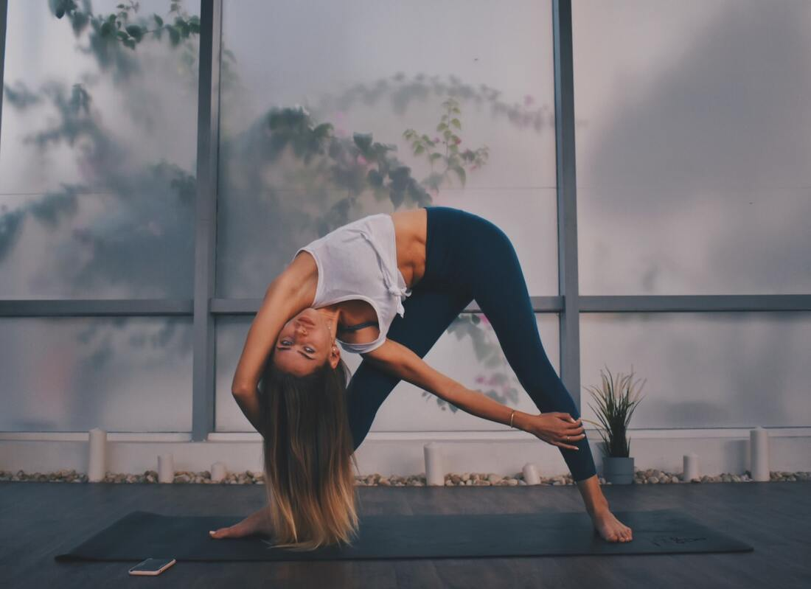
Tantra yoga for women is a much more extensive than most believe. Definitely not just about making the woman a proper receptacle a man's sexual advances.

Yoga is an ancient Indian system of postures and exercises to strengthen the body and give it greater flexibility. This promotes overall health and helps to channel the energy more profitably - whether it is sexual or spiritual energy.
Stressful and hectic pace of life today has spared no women - who are subject to fatigue and exhaustion of men. Tantra yoga is a refined form of the sciences of ancient yoga calms the mind and promotes energy. It's very different from conventional forms of exercise, they tend to consume energy in sports and other vigorous exercise, while tantra yoga actually generates energy. Taught by an experienced teacher of tantra, tantric yoga is actually a great benefit for the modern woman.
In Tantric yoga, slow and steady movements are used to segue from one position to another. The practitioner holds each position for a certain period of time, breathing calmly and without haste. A complete sequence of tantra yoga is usually followed by a period of silent meditation. The tantra teacher overseeing the process often provides instructions for calm and suggestions to induce this state of meditation.
Tantra Yoga is an ideal way for women to regain their health and wellbeing. The very nature of this system is meekness, which is the essential virtue of the divine feminine. There is very little danger of injury in case of tantra yoga is practiced under the guidance of an experienced tantric master.

At no time is a student of yoga requires moving beyond the limits of endurance. The emphasis is on gentle movements, balanced and symmetrical postures stretch, tone and energize all parts of the body. The emphasis on symmetry and balance brings mental and emotional balance, too.
Contrary to misconceptions, women of all ages can practice tantric yoga, without limitations. A teacher of tantra well be able to modify and customize the postures and stretches to the age and physical condition.

Tantra Yoga is a system of effort, powerful and effective that can do wonders for women of all ages and body types. If a woman wants a healthy lifestyle, free from tension and stress, you can certainly learn tantra yoga in a qualified tantric master.
To answer a final question that will undoubtedly arise in the mind of the reader - yes, tantric yoga also revitalizes the woman's sexual experience and enjoyment. Both physically and emotionally, this system allows you to reach their full sexual potential. However, this is not the main goal of tantra yoga. It is simply one of the many benefits it brings.

Yoga To Improve Digestion

Yoga is one of the oldest and reliable methods to lose weight and stay fit and healthy. Positions Yogasanas or intend to work smoothly on your organs and help maintain the perfect balance between mind and body.

Asanas act more subtly in the digestive system, eliminating the problems associated with the stomach. Many studies suggest that yoga is an ideal solution for many digestive problems. Yoga can get rid of digestive problems such as heartburn, acid reflux and other digestive disorders naturally, without the use of drugs. Practicing yoga relaxes your mind and in turn is reflected in the digestive system. You can see results within weeks.
Among Yogasanas significance for digestive disorders, here are some of them.
Mudrasana or mental Yoga Union Pose: You should sit in the lotus position or posture easy, Sukhasana. As you inhale, draw the hands on the back of your body, raise your hands and keep your fingers tightly. Exhale, bend the head and try to touch the ground with his forehead. Stay in this position as long as you feel comfortable. Relax and get to the point of departure. Try to do two or three times.
Benefits: Helps relieve constipation, improves the body's metabolism.
Udarakarshanasana or abdominal twist pose: first kneel and then have to sit on the fingers. Push the left knee to the ground. As you exhale, move your left hand on left knee, while keeping the knee down. Now inhale, move your right hand on right knee and press hard to the left. Exhale, you need to look over your right shoulder. Inhaling, come to the starting position. You do it three times. Take a break and do the same procedure with the other leg.
Benefits: This posture tightens the stomach muscles and blood flow increases stomach. Helps relieve constipation and other digestive problems.
Supta Vajrasana or lying beam: Beginners can start with one called matsyasan asana or fish pose. In this position, inhale and sit on your heels. Exhale. Once again while inhaling, lean back, with the support of his hands gently on the floor and rest your head on the floor. The back and neck should not touch the ground. They will be in an arched position. Place your hands on your chest in a position of Namaste (greetings of the Indian way, joining their hands). The knees should touch the ground. Stay in this position as long as possible. Return to starting position. This is an advanced pose. If you have knee problems, not recommended.
Benefits: The abdominal stretch increases the body's metabolism and aids digestion.
Breathing exercises, asanas Apart from the list above, various breathing exercises that are part of yoga, the benefit of your digestive system. The slow and relaxed breathing helps control your thoughts and stress. When you are calm and relaxed, the overall effect is shown in the body's ability to digestion.
Shavaasan relaxation and postures also help to control your thoughts, stress your body and help maintain peace and stability.Several reputable yoga teachers conduct classes. Many boot camps are also offered yoga sessions from time to time.

How To Improve Flexibly With Yoga
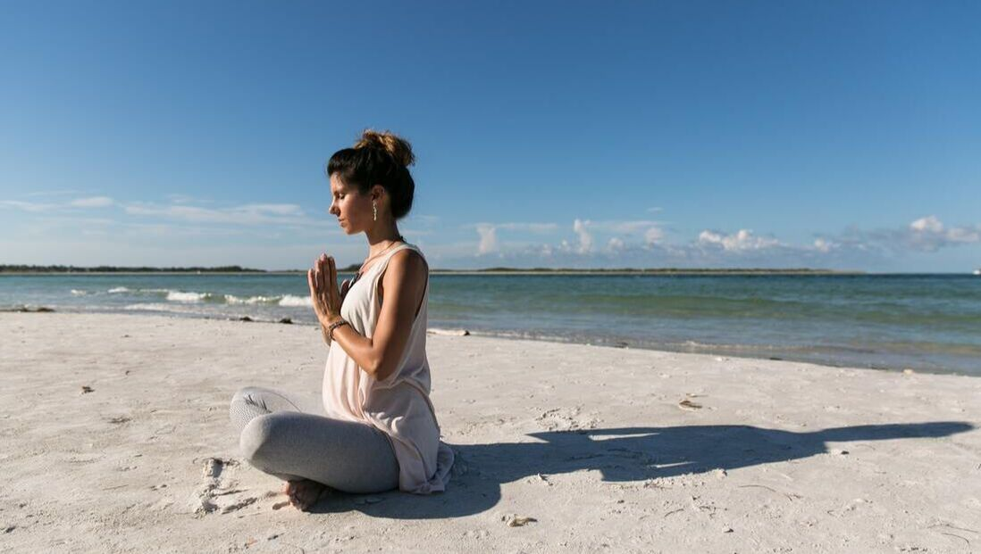

One of the many benefits of yoga is flexibility. In this article we cover a brief definition of flexibility followed by 7 simple yoga stretching exercises you can practice to improve your range of motion.
What is flexibility?
Flexibility is the ability of a joint or muscle group to move through its full range of motion. There are different types of flexibility and different range of motion / movement (ROM) for different muscle groups or joints.
What are the different types of flexibility?
There are two basic types of flexibility according to the type of movement in question.
1. Dynamic Flexibility - involves the movement of the limb through its full range of motion in the joints, for example, a service in tennis.
2. Static flexibility - have nothing to do with the movement
What is the range of motion (ROM)
The range of motion / movement is the amount of movement of the joints can move in different directions, flexion, extension, adduction, abduction and rotation.
Yoga stretching exercises improve flexibility
If you're like most beginners yoga most likely will not stretch or move your joints through their full range of motion. We are creatures of habit, and if you have a sedentary job office or spend all day driving the chances are your range of motion is limited to tasks related to regular work. Even at home, most people do not move your joints through their full range of motion. Over time, the lack of use leads to reduced mobility and stiffness, especially as you get older and less active, everyday activities like walking up the stairs, lifting or bending can be difficult and uncomfortable.
Yoga routines increase flexibility and expand the range of movement around the various joints. Most yoga postures help improve static flexibility, which increases its overall ability to stretch and be flexible off the mat.
Side note: I remember a student of yoga yoga began when her daughter had a baby and my son realized as rigid and inflexible that it had become after caring for her grandson. It was hard to look and play with it. After a few short yoga sessions, my son said that he found it easier to play with his grandson because he had more mobility in the shoulders and back and knees do not hurt either steadily and bent down to pick him and his toys up!
Here are seven simple yoga stretching to improve flexibility
As with any form of exercise, take care, respect and patience for your body, consult your doctor before embarking on an exercise program. As practice, be polite and move slowly in the leg. Any form of discomfort or stress, please stop and rest.
As you practice this routine, pay attention to your breath, breathe slowly and deeply and exhaling through your nose while concentrating the knowledge of the part or parts of the body where you feel the maximum stretch.
One: Stretch neck sideways:Take a long deep breath and exhale slowly lower your right ear towards right shoulder. Breathing and head back to an upright position. Exhale and lower your left ear toward your left shoulder. Breathing and head back toward the center. Repeat 3 to 5 times each side.
Two: the head to chest:Take a long deep breath and exhale slowly. Lower your head toward your chest, keep in mind the stretch in the back of his neck. Gently lift the head to foot. Repeat steps 3 to 5 times.
Three: Stretch:Arms over your head - standing or sitting, lift your arms straight above your head. Interlace fingers and turn palms up. Have from three to five rounds of deep breathing and stretching as you keep up. If you can, try to keep your elbows to the side or behind the ears as you stretch. Little by little fingers spread and arms gracefully down the sides. Repeat two more times.
Four: Hands behind your back:Interlace your fingers behind your back. Gently bend forward. Stretch your hands and arms up and back. Breathe into the stretch. Slowly release your arms and return to a vertical position. Repeat steps 3 to 5 times.
Five: Seated Forward Bend - Sit on the floor or bed with your legs straight out in front of you, toes pointing up. Inhale and bring the arms parallel to your ears. Stretching the spine. Lean forward from the hips, keeping your back straight and lift your hips. Hold your legs whenever convenient as allow the head, neck and shoulders to relax while keeping your chest open and your eyes looking forward. Hold for 3 -5 rounds of deep yogic breathing. Inhale, stretch your arms and repeat the pose again.
Six: Lie on your back. Hug both knees to your chest. Curl your body into a small ball. Rock gently from side to side 5-7 times. Lower your head to bed, still with knees to your chest and take 3 to 5 deep breaths in and out. Gently move the knees from side to side, giving a gentle squeezing action of the muscles of the back. Lower your feet to the bed and slowly stretch your legs.
Seven: Sit on the floor with the soles of the feet together. Lengthen your spine and relax your shoulders and jaw. Smile. Place your hands gently on your knees and allow your breath to relax and relieve any tension that may be felt in the groin. Stay focused on your breath for 3 to 7 rounds as you breathe into the stretch. Relax and free your legs.
To improve and maintain flexibility
Repeat these seven simple stretching exercises of yoga. Over time it will be easier to enter the final straight and stay in position more breaths, you can also relieve your body of tension and stress and feel calmer, cooler and able to move gracefully through your day .

Health Benefit Of Yoga

Yoga has become a very popular exercise in recent years. About 11 million Americans use yoga as a form of exercise and relaxation. Many people use yoga for body, mind and soul through the various postures or asanas. The combination of yoga postures with breathing function of the physical body and improve mental health. "The physical benefits include greater flexibility and movement, but also to improve muscle tone and strength, lowers blood pressure, increased mobility, improved hand-eye coordination, better posture, and more.

Yoga force energy. yoga sessions for relaxation, energy and suffer from back pain for people with MS. The psychological benefits of yoga in levels of depression and anxiety, improve concentration, memory and the total concentration Yoga, hostility., improving mood and increasing the capacity of a society, among other benefits.
Yoga has been practiced for thousands of years. Combine the ideas, old theories and observations of the organization and proven by modern medicine.

There are many different types of yoga. Hatha yoga is the most popular. Many describe it as the basis of yoga. This form has been in the 15th century in India developed. The different forms are developed in the style of hatha yoga. These include energy, Kundalini, Ashtanga Bikrah and styles.

The asanas or postures are used to free the mind from stress and tension. They are made to relax and recharge, while the mind and body, the perfect union. The positions should be done with firmness, comfort and convenience. Pranayama is the technique of breathing in the postures. To learn to control and regulate breathing breathing exercises, inhalation, duration and sequence.
Yoga suit all lifestyles and ages, including children and elderly. There is a yoga class is ideal for almost any level of fitness, yoga, power yoga, from the beginning.
Another benefit of yoga is the small amount of space and the number of computers. The main tool is a mat. Make a rug that fits your needs and choose to learn to take the carpet, make sure you have lived. If you have a carpet, you can use a blanket.

Other materials you want to buy an exercise ball and yoga tapes. Make comfortable clothing, be capable of supporting freedom of movement. Select lean tissue uptake. Yoga pants are very popular.

They want to dress according to your needs online or at a local store. Maybe you want to join a beginner's course or a teacher to help you find the entrance. You can also use a video or a book with pictures of poses useful. You can contact your local library to see if you try before you buy.

And as always, consult your doctor before a workout, especially if you have a medical condition. Any form of exercise you choose, be sure to have fun, this will help you stay away.

Most popular Types of Yoga

There are many styles and types of yoga classes, ranging from physically demanding lessons, such as Ashtanga Yoga gentle flowing to the types of restoration, such as Anusrara Yoga. Here, we look at three popular styles - Sivananda Yoga and Bikram Iygenar.
Yoga What does it mean?
'Yoga' The word comes from the Sanskrit word "yuj" which means yoke, union, unite. Traditionally, "yoga" was seen as a way to achieve physical and spiritual balance in your life.
What is Yoga?
A typical class consists of various exercises and techniques that encourages you to release stress and tension from your body and provides a sense of inner calm and fullness of his spirit. Most classes consist of a series of yoga exercises called "asanas," breathing exercises called pranayama relaxation techniques, and in some classes, meditation and chanting.
What are the different types of yoga?
Traditionally, only one "type" of yoga, hatha yoga is. Hatha yoga is the generic term, but within this there is a broad term variations of styles and schools of yoga. "Hatha", a Sanskrit word, means the union of the moon and sun. "Ha" represents the sun or the active male and "tha" means moon or receptive female principle. This union, creating a balance between the internal and external, vigorous and restoration of our bodies basis of all yoga classes
Three popular types of Yoga
As mentioned earlier in this article we look at three popular types of yoga, Sivananda, Bikram Yoga and Iygenar.
1. Sivananda Yoga:Sivananda Yoga is considered one of the more traditional forms of yoga, and is generally considered a mild to moderate practice, with emphasis on the spiritual side of yoga.
Founded by Swami Sivananda (1887-1963), Sivananda Yoga is the sun salutation, breathing exercises, singing and twelve basic yoga poses. The teachings are based on five key principles that Swami Sivananda created better physical health and emotional wellbeing. These five keys are the teachings of adequate exercise (yoga) proper breathing, proper relaxation, proper diet (vegetarian) and positive thinking and meditation.
2. Yoga Iygenar:Iygenar Yoga was founded by Sri B.K.S. Iygenar (b.1918) and is a popular style practiced in the West. In Yoga Iygenar emphasis is placed on anatomy and postural alignment / structural body postures. Accessories (such as sandbags, straps, blocks and chair) are also used to support the position. Sri Iygenar wrote the classic book "Light on Yoga".
3. Bikram Yoga:Bikram Yoga has to be the most common type of yoga practiced today. Founded by Bikram Choudhury (b. 1946), Bikram Yoga is practiced in a room heated to 105 degrees Fahrenheit. Classes are 90 minutes long and consist of a series of 26 positions, from standing poses, backbends, forward bends and twists and two breathing exercises.
In closing, although there are many types of yoga, all schools are under the generic term "hatha yoga". Regardless of the type that the practice - Sivananda, Bikram Iygenar or the goal is the same, to improve their health and achieve a sense of inner harmony and balance.

What is Bhakti Yoga
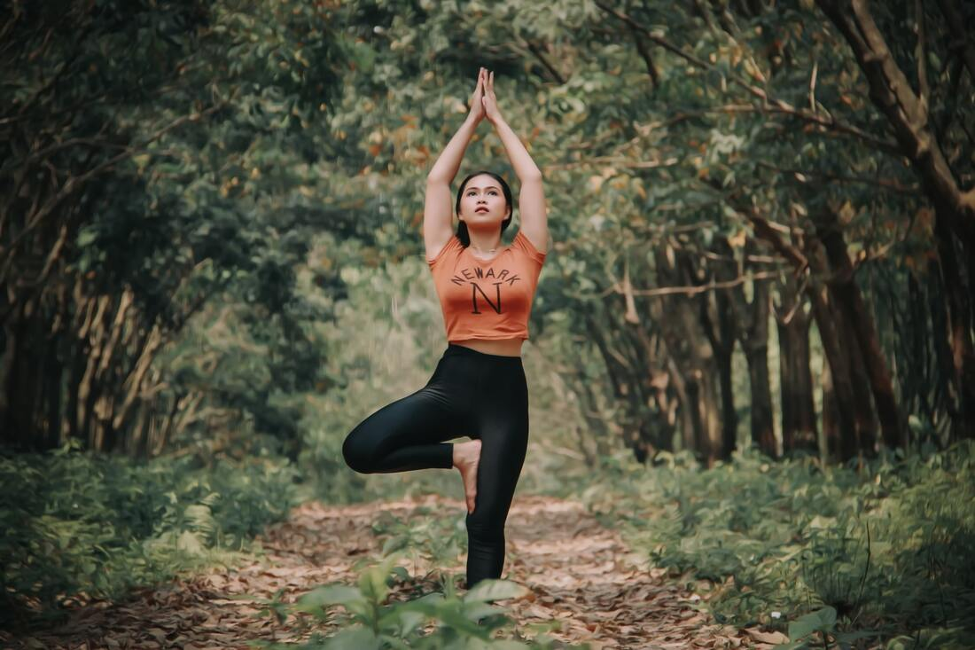

Bhakti is a type of yoga that focuses on devotion to a superior being. Its purpose is to achieve a better bond with the divine. Can be considered the most "spiritual" all styles of yoga, but a misonomer because all Yoga is inherently spiritual.
One need not be a genius to get very involved in this yoga. It is truly a call to every man and woman, giving a sense of security and a close relationship with devotion. Some seek Yoga of physical force, while others seek Yoga for inner mental strength. While this applies both inside and outside, the real appeal of Bhakti is the strong focus on the inside.
This yoga believes that a much higher power created the universe and the universe. By using the energy of this higher power, a doctor can experience the grace and mercy. This in turn is supposed to protect them from harm. A devotee of Bhakti yoga focuses on making themselves fit to be able to receive this grace. That's where practice comes in.
The owner must have an end goal in mind. That goal is "to be one," or unite with the divine power that flows through everything. Is considered a form of surrender. Bhakti professionals give to issues like good and evil, leaving the will of divine power to choose. This is not a true discard to be good, only a finding that there are some things that are not able to affect.
But do not forget that this yoga is also physical. Yes, there is an emphasis on the spiritual, but there is a physical component part!
Devotion and faith are the key principles of this style. A doctor is expected to be more religious works. They need to take a friendly attitude towards all living beings (including animals, and here is where veganism). They must be well read on religious topics, and want the best for every living person or animal.
There's a real simplicity of Bhakti Yoga. By focusing on the divine aspects, has become one of the largest and most styles of yoga attractive practiced today. Anyone looking for a deeper peace of mind to enjoy this yoga and would benefit greatly from trying. And what is the ultimate goal of life (through yoga)? The true inner peace.

Yoga For Beginners
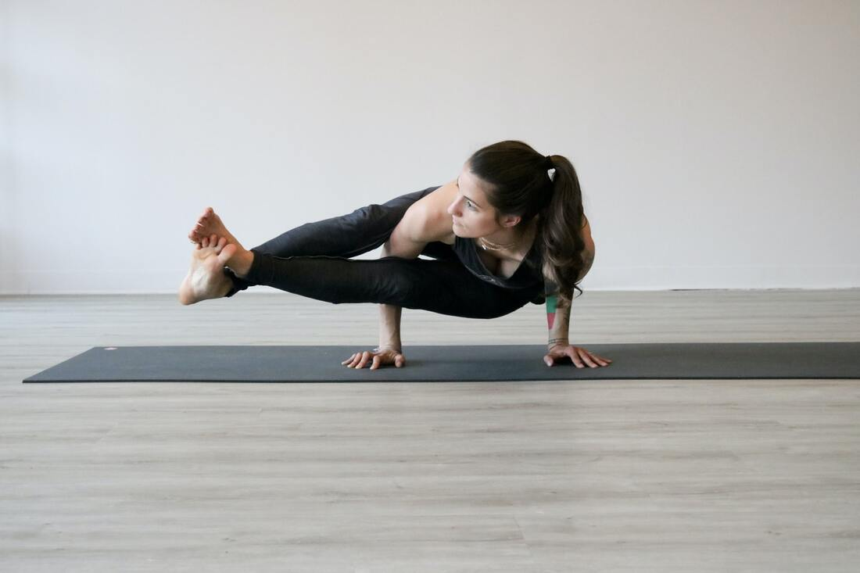

If you are looking to create more balance in your body and increase flexibility and strength, yoga classes may intrigue your interest. Yoga teaches you to stretch so that you never thought possible. Each of the postures and poses done through yoga has health benefits. Faster movements will create a sensation of heat in the body.

Slower movements are known to increase endurance and improve alignment. Poses are similar for all but the ways in which a yoga teacher approaches may vary. Once established in a yoga program, you find "your own practice" is similar, but you can always do the different methods that keep the movements become boring.

When an instructor says it is doing "his own practice," this is your place of yoga movement, which is suitable for you. One great thing about yoga is that there is no competition in question. Everyone does the best they can do. The beauty of this is that you are on your own personal space to do their best according to the leader's guide.
If the intrigues of his interest in yoga, a little research may be needed to find the right type of the class for you. There are different types of yoga practices. There are two in particular, known as hatha vinvasa and are more suitable for beginners. These formats will review the basics of yoga.

As they get used to the movements and stretching, and begin to understand how this process affects your body, you can switch to more advanced types of classes. The key factor is that all of this progression is at your own pace without pressure to move faster than they are ready.
With today's online capabilities, it can be a lot of resources in the search for yoga classes in your area. Local newspapers and magazines welfare-oriented also provide list of yoga. If you belong to a gym or fitness center, maybe they can offer a yoga class. Neighborhood park districts can have yoga classes, too.

Since you are just starting out, make sure you are inquiring about a beginner's class for a chance to learn the basics. If there is absolutely no yoga classes in your area, or not offered at times convenient for your schedule, instructional video rental purchase a beginner and have a chance in the next over.
Before your first class, ask that you need to get started. You will most likely be asked to wear comfortable clothing with clothing that is breathable. You will want to have a yoga mat. These often can be rented from the coordinators of the class.
As for some suggestions, to abstain from heavy meals before yoga classes, but eating something light before the hour. Drink fluids before or after class only.

Do not wear socks or shoes. Let your teacher know you are just beginning. Do not be embarrassed to seek help. And, most importantly, do not wait a few days before returning for another class. Once you start, you need to maintain momentum.

What is Vinyasa Yoga

Vinyasa Yoga has become a very popular style of yoga in the USA, and around the world. You may know it as vinyasa flow, power flow, hot vinyasa, jivamukti and many others. In fact, there are so many variations it can get quite confusing. Here, I will explain what vinyasa means, where it came from, and what actually makes a vinyasa yoga class.
Vinyasa means movement breathing system, or, more specifically, "sequential movement that interlinks postures to form a continuous flow". The vinyasa method is part of the ashtanga yoga system, and has been from it's beginning...said to be thousands of years ago. So, "vinyasa yoga" is a very broad categorization describing any yoga class that utilizes this breathing movement system.

There is really no philosophical direction, rules or sequences to follow. When we link breath to movement, an internal heat is created that will purify the body from within. The dynamic nature of the vinyasa method has captured the curiosity of many practitioners, especially athletes. Variations of this style have bubbled up all over the United States and abroad.
You may be wondering what to expect if you were to attend a vinyasa yoga class. What actually happens in class is entirely up to the teacher, his/her personality and yoga background. In some cases, the teacher will ask "any requests? What would you like to work on today?" (IMO, this isn't teaching).

You will likely be taken through a short breathing exercise and/or meditation, some sun salutations, a combination of standing postures, then to the floor for seated positions, possibly some back bending and ultimately, a few minutes of rest. The order of the postures may be random, or, some teachers may actually put together a progression in which each posture you do will prepare you for the next.

The only thing for certain is that each class will be different. Also, a specific teacher will likely not teach the same class from one day to the next. As with any yoga class, learn to, and work on breathing properly (this is the most important in yoga). Also, listen closely to the teacher, work within your own ability, and don't compare yourself to other students in the class.

Because this style lends itself to variety, try several different classes with different teachers until you find one that suits you. Finding a teacher that you connect with will likely keep you going back to class. Most of all enjoy the experience!

