[Date]
Massage Benefits

Beneficial Of Massage Therapy
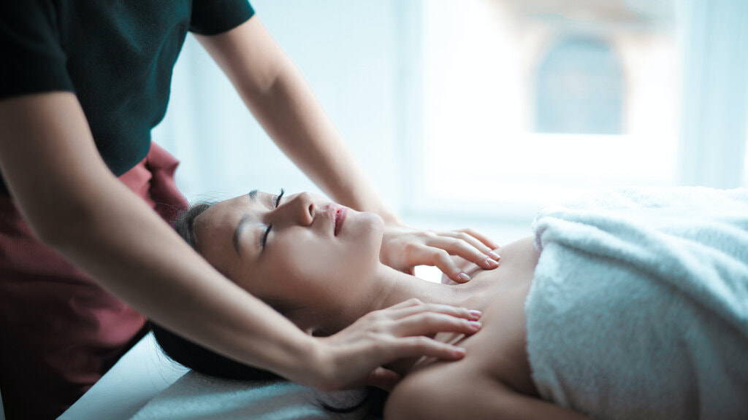

Although massage has been widely accepted as an alternative treatment and an effective method to prevent certain health conditions, there is still a lot of people who are not convinced of its benefits. At the same time there are some people who also think it's just a luxury and not worthy of your hard earned money. But go ahead and read this article to better understand how massage can help you save money in the future.
First, you have to understand that massage therapy not only relaxes tense muscles, but also relaxes your mind and spirit. Not only that massage therapy improves blood circulation and lymphatic system. With better blood circulation, sufficient nutrients are properly delivered to the body's vital organs.
It also helps in removing toxins from the body and, therefore, improves your immune system. The lymphatic system is our natural defense system. When it flows correctly and properly, our body is able to fight bacteria that cause different types of diseases. Then, it reduces body aches. Pain in the back, shoulders, neck and buttocks are the most common body aches . These pains are caused by tension and stress.
If not relieved, can only worsen. Receiving a regular massage, you are free from pain and prevent it from getting worse. Also reduces fatigue. For people who have mobility problems, massage can help improve your range of motion. However, this should only be performed by licensed massage therapist, trained and experienced. This is to make sure everything is carried out with care and safety. People with sports or exercise-related injuries can greatly benefit from regular massage.
Furthermore, it also improves digestion. The veining is also enhanced. If you have a baby, then he or she is giving a regular massage can help prevent digestive problems that are common among children in this age group. Massage is relaxing, but not only soothe and comfort as well. This is the reason why people with aggressive behavior can greatly benefit from this therapy.
With regular massage, aggressive behavior will be placed under control. And because it gives people a feeling of relaxation, but also helps people suffering from depression. This helps them achieve a more peaceful and healthy state of mind. People who have sleep disorders and other emotional problems can also benefit from regular massage therapy. And last but not least, it also speeds up recovery after surgery, as it helps in the regeneration of muscle tissue.

Benefit of Neck And Shoulder Massage
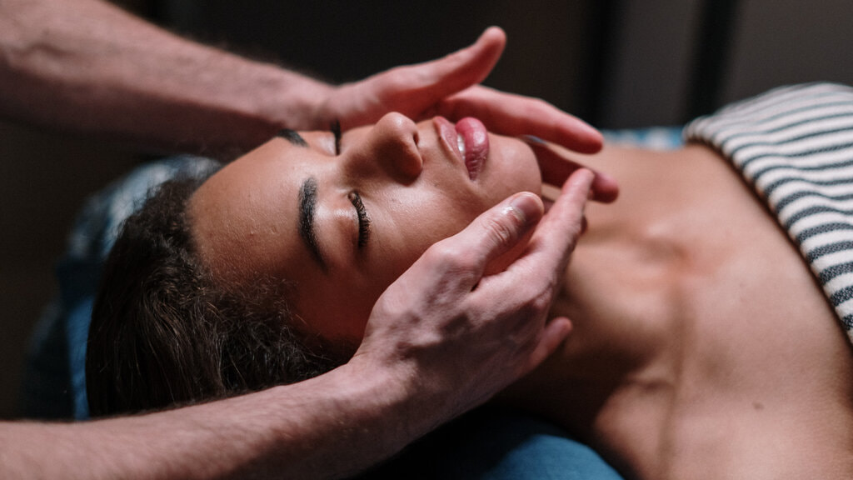
Massage of neck and shoulders is a great way to help relieve stress and tension that your spouse or friend may be feeling, and you will find that the neck and shoulder massage is really one of the easiest forms of massage. After all, the only person who has to sit up straight directly in front of you in order for you to easily give the massage.
There are many massage practice offering professional services, however, would also be useful (and fun) if I knew how to do it yourself. Here are some tips on how to give a good neck and shoulders:
1. Have the person sit in a chair with lower back as it will help you get good access to the shoulder muscles. If you have a low chair to lie on the floor. Make sure your arms are extended to both side of his body or out of both sides. This helps the muscles of the shoulders and neck as accessible as possible.
2. A unique form of massage is "piano" on his shoulders. Simply place your four fingers on his shoulders and simulate the movement you make when playing the piano. Move your fingers around his shoulders to give a deep massage with the fingertips.
3. Form your hand into a fist and place the knuckle of your index finger on his shoulder muscle. Outward Roll your wrists to put pressure on the muscles with every knuckle on, and repeat this 100 times around the shoulders. Use both hands to perform this liberation movement of the tension that helps relax the shoulders.
4. Have the person lie on your back, and put a towel under your neck. Place your hands behind the head of the person holding the neck joins the skull. Gently pull towards you as you turn your head from side to side (be sure to pull very gently), and this helps to relax the neck muscles as you stretch.
5. Search the crest of the muscles that run down both sides of the spine, and use your thumbs to gently press on these muscles. Run your thumbs on the base of the neck all the way to the skull, as it helps relax the muscles.
6. Place your thumbs on the spine, and use the index and middle fingers to gently press on the muscles on the side of the neck. Knead gently with circular movements, and go from bottom to top and back down. Be careful of these muscles gently knead as it can be very sensitive and can hurt if you put too much pressure.
7. Do not just focus on the muscles of the upper shoulders, but knead the muscles behind the neck and running down behind the shoulders.

The latissimus dorsi muscles can become tense, and you'll find these muscles gently kneading can help relieve stress very effectively.
8. Pull the head very gently towards you, making sure not to pull too hard. You do not want to extend the neck too, but simply want to be sure that the neck muscles holding the head have been removed through the stretch.
9. Have the person sit as straight as possible when given a massage in a seated position. They may find that the tension in your shoulders and neck part will dissipate when they sit up straight, and may not have to take a long massage to help resolve the remaining strains. It is important to always sit up straight and good posture.
Good posture can help eliminate neck and shoulder pain, so we always sit and stand as straight as possible in order to reduce any pain or discomfort.

It is essential to seek expert advice and treatment if the condition becomes more than a mild nuisance. There are many professional massage clinics that can offer this service.
Always check that the therapists have industry recognized credentials, testimonials from customers who can afford and most importantly, that you feel comfortable and relaxed with them.

Best Oil For Ayurvedic Massage
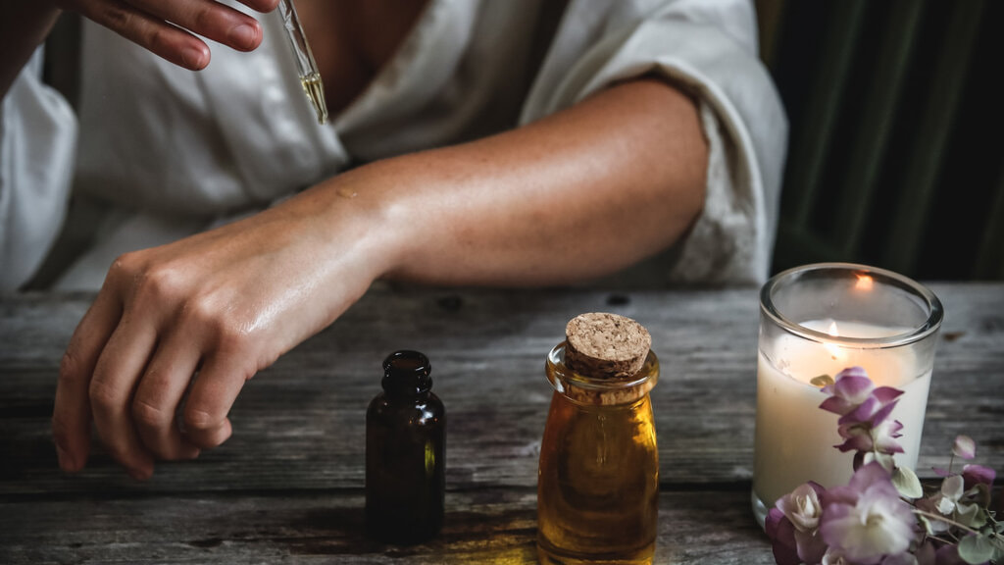

Here are nine essential oils perfect for massage you can incorporate into their massage sessions for your clients or raise body experience. In addition to raising the customer experience in general, can also improve the quality of your massage or bodywork practice.
1. Sandalwood
It is native to Southeast Asian countries. Among his other important properties, sandalwood is a sedative, tonic and memory booster. For the massage, the first two are very beneficial. As a sedative, sandalwood is very effective sedative in anxiety, fear and anxiety, as it induces a calm and positive thoughts. I like the third property, because I like to think that will help keep my client how great was our session. What it does is keep the brain fresh and relaxed, freeing them from undue stress and / or anxiety.
2. Bergamot
It is from a citrus fruit called bergamot orange, originated in Italy. It should smell sweet, best known for its use in Earl Grey tea. It has many favorable properties, but for the purpose of massage, the most important are that it relaxes the nervous system and relieves stress and tension. An added advantage is that it will give the skin a healthy glow.
3. Clary Sage
It is produced in the U.S., France and Bulgaria. It has to be one of my three best oils of all time. It has a wonderful aroma that is quite earthy and herbaceous. It also has an almost narcotic and euphoric, even that is ideal for stress relief - for both the client and therapist! It is also an antidepressant, which helps build self-esteem, confidence, hope and more. After massaging a client with sage, you can see a whole new person emerge from the table that is full of confidence, great joy and good humor.
4. Chamomile oil
It is a very powerful soothing and calming. It is also very versatile since it can be successfully blended with other fragrances for maximum effect. I prefer the scent of chamomile, which is almost like an apple, or German chamomile essential oils Moroccan. Compared with oil perhaps more popular, Lavender Chamomile, Roman, while more expensive, is actually more efficient and requires a smaller amount. May be irritating to the skin if not sufficiently diluted.
5. Lavender
With its sweet aroma, floral and herbaceous scent is the best known and used in everything from the potpourri of laundry detergent. It mixes well with other fragrances such as cedarwood, sage and nutmeg. What makes lavender so popular? There are thousands of reasons for its popularity, but I suspect the most likely reason is that the smell is very soothing and immediately. In addition, relieves anxiety, depression, nervous tension and emotional stress. It also induces sleep, so for the massage, the smell is almost perfect.
6. Peppermint
It is native to Europe and is a cross between spearmint and watermint. Similar in popularity of lavender, mint you will find many products on the list would be prohibitively long for this article. The health benefits is an equally long list. For the use of massage, peppermint provides relief from depression, mental exhaustion and stress due to its refreshing. It is also very effective for anyone suffering from anxiety or concern. A little goes a long way and much can actually aggravate the skin.
7. Cedar
Extracted cedar tree through steam distillation. I love the smell is very earthy and woody. It blends well with lavender and other essential oils. It is also a relaxing large reduction of anxiety and nervousness.
8. Nutmeg
It is native to the Banda Islands in Indonesia has a warm and spicy scent. Among a long list of healing properties, nutmeg is an anti-inflammatory, a very strong painkiller, can also be a tonic for the body by reducing fatigue and weakness. Of course it is ideal to relieve depression and anxiety as well.
9. Ginger
It is native to India, where its name comes from the Gingi area of ​​India. Can be combined with bergamot and sandalwood essential oils for a very pleasant and efficient mixing. It can relieve muscle aches and even lethargy. I personally do not recommend using essential oil of ginger alone in a carrier oil. It is especially suitable as complimentary oil, mixed with others.
These nine essential oils suitable for massage can be used separately or combined to create special mixes for each client. Can be used as aromatherapy by inhalation, or combined in a suitable carrier oil to be used directly in the skin. It is important to remember that some people may be allergic or sensitive to oils.
Always ask your client if you have any known allergies. For example, I am very allergic to eucalyptus and I can not tell you how many times you tried to kill me for using it in me without asking first. Also, some oils are stronger than others, so be sure to take special care in their application directly to the skin. This list is intended as a suggestion for those therapists seeking to expand their horizons.
I recommend using organic essential oils whenever possible. Not only is it a selling point for customers, but when working in direct contact with massage media for hours every day, which are potentially absorbed into his body through his hands what chemicals were used to produce non-organic product.
Disclaimer: This is a list of my favorite essential oils is for informational purposes only. It is not intended to be used as a recommendation to treat, cure, prevent or diagnose any disease or condition. I urge you to further investigate each of these nine essential oils for massage perfect if you think you might want to integrate into your own massage or bodywork practice.
If you have not had any training in the use of essential oils, it is important to know should never be used undiluted. Keep out of reach of children because it can be extremely dangerous if ingested. Again, make sure to ask your client about any allergies or skin sensitivity, even conducting a test on a small section of a sensitive area of ​​the skin (remember to dilute the oils properly before application).

